Green City R-1 is excited to announce the launch of the official Green City R-1 Facebook page. This page will be used to share information about announcements and upcoming events. This page will also be used to share information about all the wonderful things that are happening at Green City R-1. | 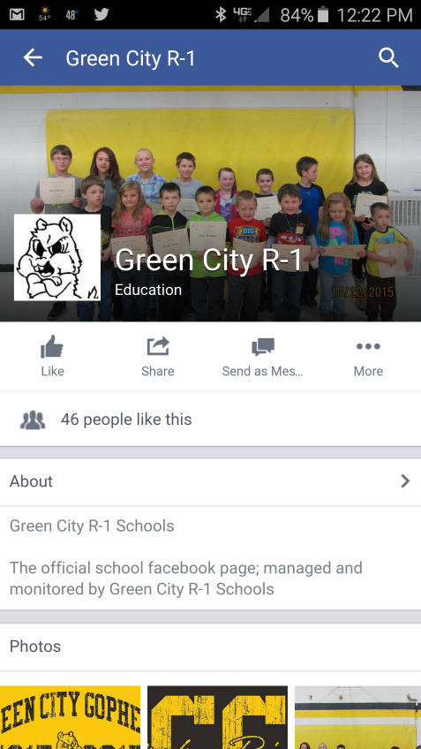

As a reminder, student information and their images may be shared on the Facebook page. On the back of this sheet is the directory information that is provided to families each year in the student handbook. Please contact the school if you have any questions about the public directory information.

DIRECTORY INFORMATION
The Family Educational Rights and Privacy Act (FERPA), a Federal law, requires that Green City R-1 with certain exceptions, obtain your written consent prior to the disclosure of personally identifiable information from your child’s education records. However, Green City R-1 may disclose appropriately designated “directory information” without written consent, unless you have advised the District to the contrary in accordance with District procedures. The primary purpose of directory information is to allow the Green City R-1 to include this type of information from your child’s education records in certain school publications. Examples include:
- A playbill, showing your student’s role in a drama production;
- The annual yearbook;
- Honor roll or other recognition lists;
- Graduation programs; and
- Sports activity sheets, such as for wrestling, showing weight and height of team members.
Directory information, which is information that is generally not considered harmful or an invasion of privacy if released, can also be disclosed to outside organizations without a parent’s prior written consent. Outside organizations include, but are not limited to, companies that manufacture class rings or publish yearbooks. In addition, two federal laws require local educational agencies (LEAs) receiving assistance under the Elementary and Secondary Education Act of 1965 (ESEA) to provide military recruiters, upon request, with three directory information categories – names, addresses and telephone listings – unless parents have advised the LEA that they do not want their student’s information disclosed without their prior written consent.
If you do not want Green City R-1 to disclose directory information from your child’s education records without your prior written consent, you must notify the District annually by September 1 of the current school year.

Green City R-1 has designated the following information as directory information:
Note: an LEA may, but does not have to, include all the information listed below.

Name | Participation in officially recognized activities and sports
Address | Weight and height of members of athletic teams
Telephone Listing | Degrees, honors, and awards received
Email Address | Most recent educational institution
Photograph | Dates of attendance
Date and place of birth | Student ID number, user ID or other unique personal identifier used to communicate in electronic systems that cannot be used access education records without a pin, password, etc. (A student’s social security number, in whole or in part, cannot be used for this purpose
Grade Level

